“Figure-to-data” map

This template is designed to aid in the organization of raw and manipulated data files as you prepare for publication or presentations and to fulfill requirements for open access policies. This template can be uploaded with your data to be used as a “key” for locating data that is associated with figure/table creation. This template was designed using a folder hierarchy digital filing system, as shown in Figure 1. It is strongly recommended researchers to use a filing hierarchy system similar to the one described to enhance efficiency of locating data files and maintain good research practices. For more information on best practices for this type of framework, see: http://www.damlearningcenter.com/resources/articles/best-practices-for-folder-organization/.
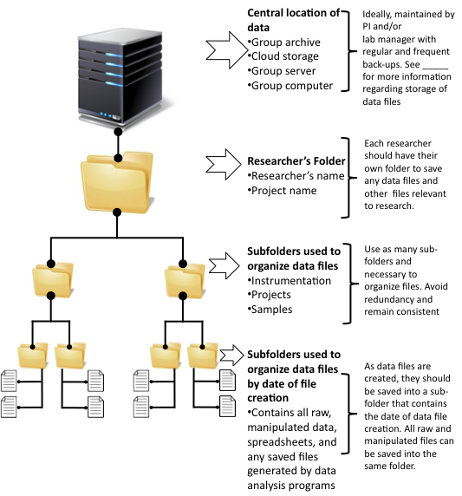
Figure 1: Illustration of folder hierarchy filing system used to create template

Follow the flow chart to determine which template(s) is/are best suited for your figure(s)/table(s). Dotted lines represent information that will be included with the template.
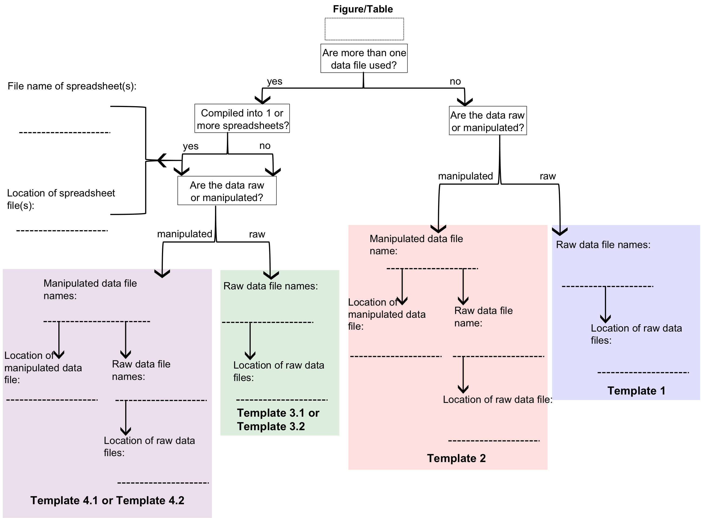

Directions: Complete this template as you prepare for publications, presentations, and sharing of data. Use the flow chart above to aid in the determination of which template is best suited for your figure(s)/table(s).

General Information (include at beginning of document to be used to map data to each figure):

Title of paper/project/presentation:
Abstract:
Total number of figures/tables:

Template 1: Raw data file with no further manipulations (ex: images from microscopy, NMR spectroscopy, etc.)
Title of figure/table:
Figure/table number:

Description of figure/table (figure/table caption):
Program used to display(create) figure/table:
Raw data file name:
Raw data file can be found (location):

Template 2: Data file that has been manipulated from the raw data file (ex: images from microscopy that have been analyzed with another program, spectroscopy with background corrections, etc.)
Title of figure/table:
Figure/table number:

Description of figure/table (figure/table caption):
Manipulated data file name

Manipulated data file can be found (location):

Program used for data analysis:

Types of manipulations performed:

Raw data file name:
Raw data file can be found (location):

Template 3.1: Multiple raw data files with no further manipulations without compilation into spreadsheet software (ex: multiple NMR spectra, etc.)
Title of figure/table:
Figure/table number:

Description of figure/table (figure/table caption):
Program used to display(create) figure/table:
Total number of data files used for figure/table:

Raw data file information
Raw data file name: | Raw data file location:
Template 3.2: Multiple raw data files with no further manipulations with compilation into spreadsheet software (ex: multiple absorbance spectra, patient information from medical records, etc.)
Title of figure/table:
Figure/table number:

Description of figure/table (figure/table caption):
Program used to display(create) figure/table:
Total number of spreadsheets used to compile data:
Spreadsheet software used:

Total number of data files used for figure/table:
# Manipulated:
# Raw:
Spreadsheet information
Spreadsheet file name: | Spreadsheet file location:
Raw data files information
Raw data file name: | Raw data file location:

Template 4.1: Multiple manipulated data files without compilation into spreadsheet software (ex: multiple absorbance spectra, patient chart information with statistical analysis, etc.)
Title of figure/table:
Figure/table number:

Description of figure/table (figure/table caption):
Program used to display(create) figure/table:
Total number of data files used for figure/table:

Data files information
Manipulated data file name: | Manipulated data file location: | Types of manipulations performed: |  | Software  used for manipulations: | Raw data file name: | Raw data file location:

Template 4.2: Multiple manipulated data files with compilation into spreadsheet software (ex: multiple absorbance spectra with background correction, patient information from medical records with statistical analysis, etc.)
Title of figure/table:
Figure/table number:

Description of figure/table (figure/table caption):
Program used to display(create) figure/table:
Total number of spreadsheets used to compile data:
Spreadsheet software used:

Total number of data files used for figure/table:
# Manipulated:
# Raw:

Spreadsheet information
Spreadsheet file name: |  |  | Spreadsheet file location:
Data files information
Manipulated data file name: | Manipulated data file location: | Types of manipulations performed: |  | Software  used for manipulations: | Raw data file name: | Raw data file location:

